Creating Your Patient’s List

- Click on the Work menu button to build your patient list. Any patient that has you as the attending or ordering physician will automatically populate to your my patient list.
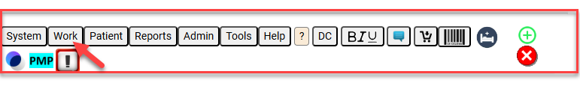
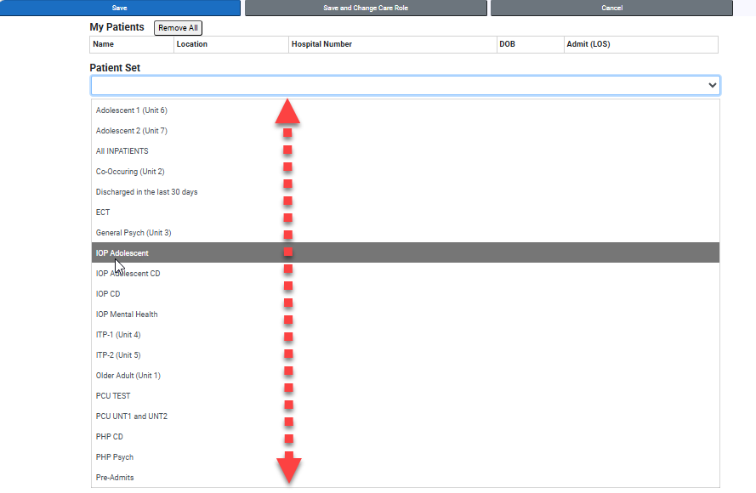
- Click on the “My Patients” tab. Choose the patient set that would include your patients. There will be a drop down with all the patients in the set.
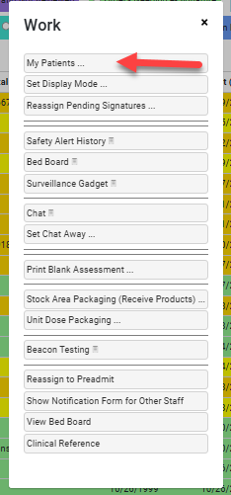

- When you click on the patient in the “Patient Set”, it automatically moves to the “My Patients” section. You can also “Add All” or “Remove All” as needed. Select the save button.

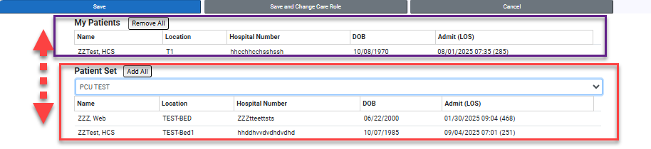
- To create different patient lists for different care roles if you have more than one role, select “Save and Change Care Role” button, then select the different role. Separate lists can be created/modified for each role.
- To add one patient that is currently selected and visible in your window to your “My Patients” list, select the Work menu button, then select the “Add Current Patient to My Patient” menu item.
